The Technical View of 2020 Census Enterprise Architecture and Infrastructure Transition Plan (CEAITP)

# IT Infrastructure

According to the definition of Information Technology Infrastructure Library (ITIL) v3, IT infrastructure a combination of tools and methods such as hardware and software to help to develop, deliver and test IT services. The goals of ITIL are cost reduction, IT services improvement, customer service improvement, technology productivity improvement delivery enhancement.

The architecture will use the enterprise cloud services. It should address the cloud solution readiness and the detailed strategy to meet the 2020 solution architecture. A lot of interfaces which are expected to use ESB and web services should communicate and share files efficiently and securely.

The enterprise IT Infrastructure should be refreshed periodically with timelines including compute resources, storage, network devices, system monitoring, and security appliances. The technology refresh timelines must be aligned with the Census Tests timelines and 2020 Architecture Transition Plan so to ensure readiness of the infrastructure components for Census Tests and 2020 Census.

## Service Oriented Architecture (SOA)

A service-oriented architecture (SOA) is an architectural pattern in which an application component provides services to other components by communication protocols over a network.

The Census Bureau has adapted SOA as a way to deliver on its mission requirement. The SOA increases the ability to adapt changes more rapidly as well as meets business and technical needs of the agency. The SOA strategy will enable the US Census Bureau to:

* Decrease architecture complexity and increases the application integration more efficiently.
* Provide the data and application APIs to systems, which are accessible throughout the enterprise.
* Deliver applications faster with lower system integration costs.
* Provide support for application services reuse and enable business functions to operate more efficiently.

The 2020 Census solution architecture is based on the SOA paradigm. The services and interfaces of one system need to share data with other systems in the solution architecture. The SOA includes not only in-house services, but also Platform as a service (Paas) and Software as a service (Saas) models.

The important part of SOA, ESB facilitates the integration of loosely coupled services within the

architecture. ESB is a common implementation pattern for SOA and its objective is to find a standard, structured, and general solution for implementing loosely coupled software services. The 2020 solution architecture goal is to transition into the ESB and be able to effectively and efficiently transfer messages and data files across the platform.

## Mobile Technology - Device as a Service (DaaS)

The 2020 Census Architecture will be transition to Device as a Service (DaaS). Implementation will allow a transition to being directly connected to the US Census network to record secure electronic data collection and transmission of Census results.

## Enterprise Cloud

Enterprise cloud computing environment provides software, infrastructure and platform services to an enterprise. Cloud computing eliminate systematic risk rising from power grid interruption and data loss due to network attacks. The US Census Bureau plans to migrate any component included in the Technical Reference Model (TRM). The fitness evaluation steps of migration process are shown in Figure 1.

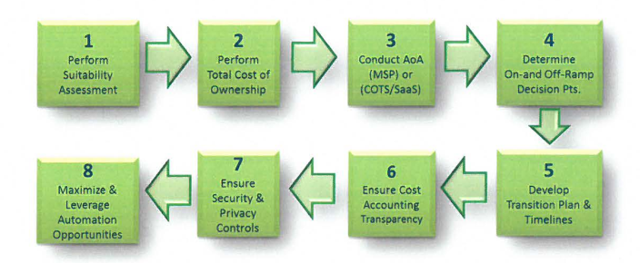

Figure 1.Key Strategic Steps for Consideration to Enterprise Cloud

* **Perform suitability assessment** on technology/architecture to determine readiness or potential for

a cloud solution.

* **Perform a Total Cost of Ownership (TCO)** including an AoA to see if a commercial managed service

provider (MSP) or COTS/Saas is more appropriate to deliver the capability.

* **Determine appropriate on-ramp and off-ramp**, either in a tech refresh, or a move to a different

cloud service provider (CSP), while considering alignment with other technologies that have

dependencies or a specific application is dependent on.

* **Ensure appropriate security and privacy controls** including records retention can be achieved with

the solution.

* **Ensure cost accounting and transparency** can be achieved with the solution. Consider what to

purchase, how to monitor and control costs, and ensure appropriate levels of service(s) are provided for payments made.

* **Develop transition plan** and schedule to include a WBS that aligns resources to the various

activities.

* **Maximize and leverage automation opportunities**- It is important to recognize possible areas and

opportunities to automate and optimize technical and business operations.

## Disaster Recovery and Continuity of Operation Plan (COOP)

The US Census Bureau places a high value on being prepared for disasters and operation continuity.

Failure from disaster recovery will lead to a loss of public confidence, risks of public safety and costly service downtime.

# Security Architecture

The Census Bureau Office of Security {OIS) has established security policies and guidelines at the

program, enterprise and system levels. In adherence with the security policies, the system owners and

program offices are required to register each system where they are responsible for its operation into

the eSDLC program. The transition to the 2020 Census architecture involves validating the security of nearly 60 systems.

# Program-Enterprise-System Quality

Quality data gathering, processing and storing is a high-priority goal of the 2020 Census. The US Census gathers data of variety nature and size some of which is considered personal and confidential. Therefore, quality in gathering such information securely is critical. The 2020 solution architecture considers four categories of quality; they are:

* Business/Program quality - Ensures governance processes, timelines, and milestones are

realistic.

* Enterprise quality - Ensures enterprise level services, integrations, and tools operate as designed

and intended.

* Data Quality- ensures the overall Census Count is accurate.
* System Quality - ensures higher-quality data capture via entry by human or machine (e.g. scanning solution), or via interfacing with other internal and external systems.

The aspects of quality, which accompany the expansion of the business functionalities, are further

described below and are presented by Figure 2, which indicates that as each solution's capabilities expand, the quality aspects of the target architecture will increase.

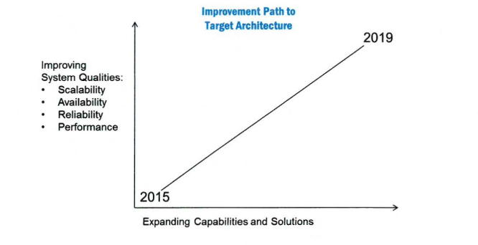

Figure 2.Quality Aspects vs. Expanding Capabilities and Solutions

## Scalability & Performance Scalability refers to the ability of a system, network, or process to adapt and handle change in workload capacity and process demands. Elasticity is the ability to dynamically provide additional resources when load increases, and to tear down unused resources when demand wanes.

Currently a 2020 Census Architecture scale-up initiative is underway led by a three stage model, the conceptual, analysis, and implement/test. The conceptualize stage starts the process by producing several artifacts. They are the demand models, and the Non-functional requirements. The analysis stage realizes the overall solution, system, data flow, and interfaces while the Implement/test focuses on execution and testing of the analyzed models, using optimization, partitioning, replication, design.patterns, scaling and continuous testing techniques. This model is shown in Figure 3.

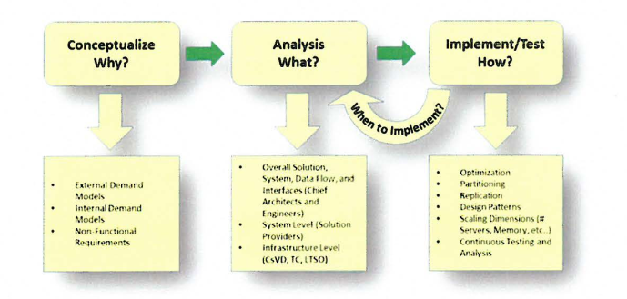

Figure 3.2020 Scale-Up Three Stage Process

The need of the workload to scale up will increase and during the transition period, the goal is to test and demonstrate the ability to scale up to full 2020 Census size. Figure 4 illustrates the Scale-up readiness timelines that the team has developed and when a scalable solution will be ready.

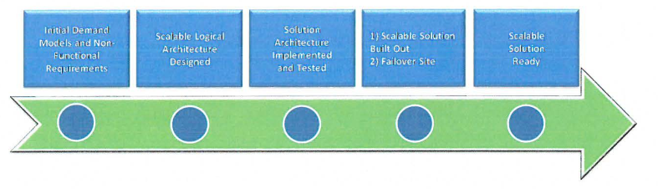

Figure 4. Scale-up Initiative Transition Timeline

## Availability & Reliability

A system is considered reliable when it continues to operate as designed and availability is the probability that a system will work as required for the duration of its mission. Availability of a solution is represented by the ratio of the expected value of the uptime (operational time) of a system to the sum of the expected values of the up and down times (operational) +(non-operational) as shown below.

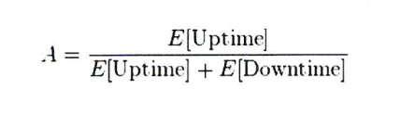

Figure 5. The definition of availability

During the transition period, the goal is to determine the accepted level of system availability for each system. This will help determine the thresholds of availability for mission critical and non-critical systems and help determine the overall architecture functional availability to conduct the census.

# Transition Approach

There are two standard approaches to develop an architecture based on the industry standard.

* **The baseline first approach** is used where an assessment of the baseline landscape is used to identify problem areas and improvement opportunities.
* **The target first approach** is used where the target state solution is elaborated in detail and then mapped back to the baseline, in order to identify change activity.

In determining the current and target states the Architecture team teamed up with various teams and

stakeholders to ensure a current state is precisely established. Figure 5 illustrates the communication and collaboration between stakeholders and program/project teams as well as the security and information engineers.

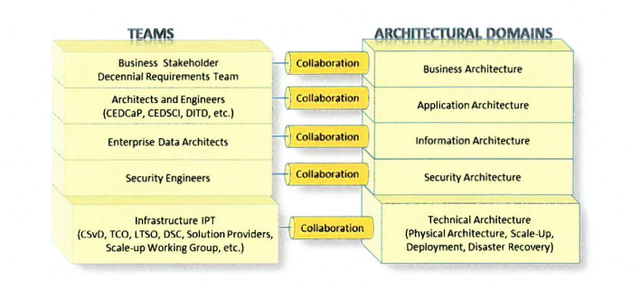

Figure 6. Architectural Domains and Team Collaboration

## Transition Steps

Transition steps need to consider the complexity and diversity of the architecture. Figure 6 defines a transition path. These steps are similar to the Enterprise Architecture Planning(EAP) model. Firstly, define where we are now and where we want to be, and then make gap analysis and work out migration plans.

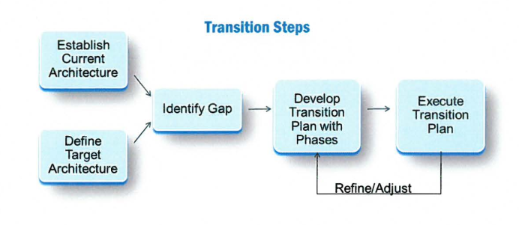

Figure 7. 2020 Census Architecture Transition Steps

## Phased Testing

Figure 7 illustrates the phased testing approach supported by detailed operation plans, GOSC and requirements as well as enabling technologies such as SOA, Cloud and Mobile. The transition is phased and promoted incrementally from its current state to the target state. For each phase test and census, a specific solution architecture diagram is developed, verified and validated by the appropriate stakeholders.

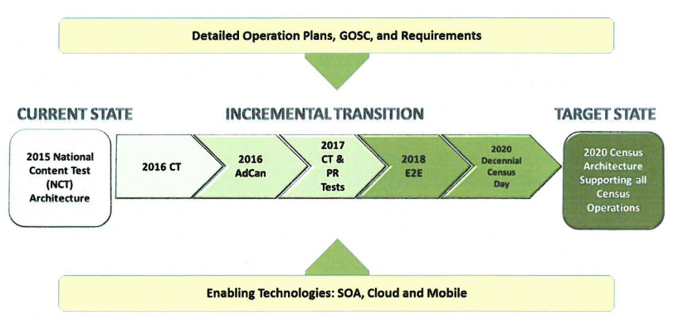

Figure 8. 2020 Census Architecture Incremental Transition Model

## Transition Tasks & Activities

To ensure timely execution of each test and census, the Architecture Team will continue to execute on   
on-going tasks and activities. Table 1 documents the transition tasks and future activities.

|  |  |
| --- | --- |
| Activity | Description |
| Finalize Target State Application Architecture | 1) Collaborate with Business Stakeholders and Business Requirements Team to  analyze the Operations that are in the process of developing the Detailed  Operational Plans, including requirements, Business Process Models, and  Integrated Operation Diagrams. One venue is to participate in the IPT sessions.  2) Identify solutions that are needed for new capabilities, by leveraging existing systems, enhancing existing systems, or designing new systems, such as Island Areas, Coverage Measurement (CM), and Group Quarters (GQ), etc. |
| Disaster Recovery and COOP | Collaborate with the COOP Team to establish and analyze the COOP and ; Disaster Recovery requirements |
| Scale-up Project Next Steps & Continuous Quality Improvement | Establish a Working Group to plan and execute the Scalability Framework encompassing the overall 2020 Solution Architecture, and all layers of the technology stack |
| IT Infrastructure Support | a) Working Group established to design the IT Infrastructure, including Field offices, in order to support the 2020 Census Operations and systems in  terms of capacity, scalability, reliability and system administration and monitoring.  b) This effort will include the analysis and design of a failover site for Disaster  Recovery and COOP.  c) Ensure the readiness of IT Infrastructure by aligning the Census Test dates  with the Technology Refresh phases. |
| Cloud Transition | Collaborate with Enterprise Services Framework Team and IT Divisions to establish a systematic plan to transition suitable systems that support 2020 Census to the Cloud environment. |

Table 1. Transition Tasks and Future Activities

# Current Architecture(As-is Architecture)

## Infrastructure Architecture

The 2015 NCT conforms to the Technical Reference Model {TRM) to guide the design of operational and

development environments and communication services for the 2020 Census solutions.

## Security Architecture

The 2015 NCT architecture was designed to be in compliance with all Census Bureau, Department of  
Commerce, and applicable government security standards.

## Quality Architecture

Data quality is a major focus of the Geographic Programs infrastructure due to their involvement with

checking for indications of growth and change and determining if the resources are available to make

updates and capture those changes.

# Target Architecture(To-be Architecture)

## Infrastructure Architecture

### Infrastructure Domains

Infrastructure encompasses several distinct domains of functionality and technology. The domains are as follows:

* Application Technology- Standards and software applications, which support the development, and integration of software applications.
* Collaboration and Electronic Workplace-Software applications, Standards and software applications.
* Networking and Telecommunications - Standards, software applications, and hardware that

provide or support computer networking and telecommunications.

* Infrastructure Platforms and Storage - Standards, software applications, and hardware that

support digital data computation and storage.

Figure 8 illustrates the infrastructure domains and associated sub-domains within the TRM

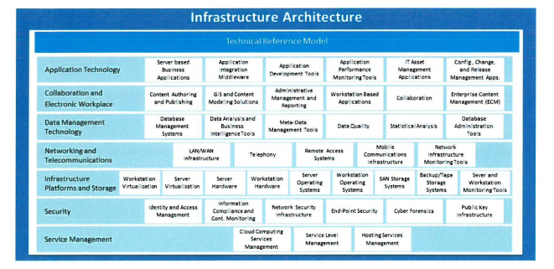

Figure 8. TRM Domains and Sub-domains

### Security Architecture

The Federal Information Security Management Act (FISMA) requires that all federal agencies document  
and implement controls for information technology systems that support their operations and assets.

### Quality Architecture

### Data Quality Management

The primary goal of the 2020 Census is to collect complete, accurate, and quality Census data.

### Data Quality in Systems

Various systems contribute to the quality aspect of the 2020 Census in two ways. The first way is

through systems that support Quality Control. The second way is through systems that have improved algorithms to support quality and efficiency modeling.